**CHAPTER ONE**

**INTRODUCTION**

1. Background To The Study

Information system is defined as an organized combination of people, hardware, software, communication network and data resources that collects, transforms and disseminates information in an organization. Today information is considered as key resources to the organizations that want to enhance products and service through more effective operations and though having better information about the operating environment, Because of this reason, organizations have to make an effort to develop SISP, which can be interrelated with their business strategies and support business missions. According to Remenji (2016), “SISP is the process of establishing a programmer and it will use IS in such a way that it will optimize the effectiveness of the firm’s information resources and use them to support the objectives of the whole enterprise as much as possible”. An information system (IS) within an organization should be established on the basis of clearly defined potential benefits Galliers & Sutherland (2015). To achieve this, the organization should have a strong and well-developed strategic information system plan (SISP) that consists of a strategy for both information planning and management, including the use of functions and features of information technology (IT) Galliers, Swatman & Swatman (2018).

Supervision has been conceived as the improvement of teaching and learning process for the ultimate benefit of the learner who is regarded as the pivot of education. In the same vein, Supervision is essentially a leadership function, a kind of superior subordinate relationship, where a leader or an officer instructs, oversees and corrects subordinate in order to enhance effective performance. Supervision is effective and efficient school activities, so that educators can really give their best in their various duties posts and as well make extra ordinary contribution to brandishing learners who will be capable of competing globally with their counterparts. Adelakun (2015).

Supervision of teacher is the means by which subordinate staff of the school are mobilized and motivated towards the full attainment of the goals and objectives of the school the serve. Supervisor ensures that the right thing is done through direction and monitoring of teacher activities in the school. That is making checks and balances to some specially assigned duties.

Key (2019) defines Supervision in education as “that phrase of school administration which focuses primarily on the achievement of education aims and objectives. He further opines that supervision is an activity which involves guiding, refreshing, encouraging , improving and overseeing the teaching and learning with the hope of asking that co-operation of the teachers in order for the supervisor to be successful in his supervisory functions.

The major goals of most nation of the world have been the achievement of educational excellence. This is so, because education has been adjudged the key with any nation could permanently close the door of poverty and ignorance, and simultaneously open the door of prosperity in terms of economic buoyancy, social advancement and civilization. Since education is accepted to be an instrument of change alongside the element of growth, teachers are the operators of the instrument while the students could be regarded as the raw materials on which the changes would be manifested over a period of time.

However, both the teacher and student input are quite important and relevant to the school system, for they are the principal actors on stage. In the process of teaching and learning, some extraneous variables sometimes interfere with the plans and patterns of operation within the school, the teacher personality his attitude to work, motivation, discipline, student background and environment which could individually or collectively have either positive or negative effects on the school system and its end results.

The process of supervision is complex and it pervades the whole structure of the school system. There seems to be little or no area of operation within the school where the need for supervision would not arise, but it may be in varying degrees. Teachers have been accused of divided loyalty, non-chalant attitude and indiscipline among the teachers and the students was also discovered. There is a constant comparison of the past with the present, more especially when the government or voluntary agencies or school inspectors are compared with those of today. Parents do complain about their children or wards inability to communicate effectively in order language apart from their mother tongue. With this, they thought the school system is fast losing its glamour and orientation, which is directly affecting the attainment of the national aims of education. It is therefore very importance for these concerns to critically look into the crucial areas within the school system that requires supervision, these are the instructional and discipline areas, were both the content method and mode of delivery and personality of both the student and the teachers are ensure their adequacy for the school system. Ajebade (2013).

* 1. **Statement Of The Problems**

The eminent problems associated with the processes and procedures, which both the students and the supervision (lecturer) encounters while supervising a project creates a great hindrance and also a bottle neck in carrying out the exercise of successfully completing a project write up.

The time constraint, limited resources, student technical and academic capability among others is the major problems associated with final year student project supervision. Specifically, the timing problems on both the student and the supervisor is very critical, so also the limited resources both financial and material alike.

This project will aim to address all the identified constraints highlighted above.

* 1. **Purpose Of The Research**

The purpose of this study is to ease the supervision process, federate the tasks of all involved actors and enhance the student-Teacher learning experience. Collected feedback from students and academic staff shows that such a system can help to maintain an effective and efficient supervision relationship between all parties.

* 1. **Aims And Objectives**

The aim of this project is to design and propose a systematic and feasible system that will enhance the project supervision and submission processes with the view of solving the identified bottle necks existing in the current system. This will be achieved through the following objectives:

1. Analyse the current system to identify the existing constraints with the aid of stakeholders’ survey.
2. Design the proposed system to tackle the identified constraints
3. Identify the right technologies to be integrated based on the proposed system design
4. Test and verify the proposed system using a simple use case scenario and stakeholders’ feedback.
   1. **Significance Of The Study**

This study will scientifically provide the solution to the distractive nature of effective supervision of a student project. It will ease both the parties effort in carrying out project right from the topic selected to the conclusion and help in grading (effective supervision) of the project by the assigned lecturer (supervisor).

* 1. **Scope Of The Study**

The study focuses on students’ project supervision process in the department of information management technology. The study attempts to improve the level of effectiveness, relevance and adequacy of the department in view.

* 1. **Research Question**

Attention will be taken and given adequately on the following question

1. How do we determine effectiveness of project supervision?
2. What are the expected roles for all parties on effective project supervision?
3. How can we promote effectiveness in project supervision?

**CHAPTERTWO**  
**LITERATURE REVIEW**

* 1. **Introduction**

This chapter gives a review of the related works on effective project supervision which provides the necessary background for the purpose of this research work and to give some ideas of the fundamentals.

The supervisory process of final year research students has attracted a lot of attention and consideration from higher education institutions around the world. Many books, articles and best practice guidelines have been produced for students and supervisors to explain this process, to increase their awareness about the main challenges and the key issues to avoid and to help them establish an effective relationship. In contrast, undergraduate and postgraduate final year and dissertation projects (i.e. those who require the production of a dissertation report at the end) have not attracted a similar focus for different sons. The requirements and the standards for a high quality supervisory process are usually left for the intuition of the module leader, the supervisor or the academic coordinator and the quality assurance manager of these types of projects. Although some supervisors and module leaders have developed some specific guidelines and pro-forma documents to ease and control the supervision process for both postgraduate and undergraduate students, they have not been supported by a central tectonic technology based system that federates the communication between all those who are involved either directly or indirectly in the supervision process. Having such a collaborative system can help to record, monitor and revisit the supervision process and enhance the student learning experience. From a student perspective, having in place a unique electronic supervision system alongside with the traditional ace-to-face and paper.

**2.2 History of Project**

Project supervision/management has been practiced for as long as humanity inhabited earth. There are many examples in history of challenging projects that were successfully completed, despite all the complexities and uncertainties that could’ve rendered the project a failure. Many of these projects necessitated an enormous workforce, large scope, many years of work, advanced planning and precise execution. Regrettably, despite all of these monumental achievements, very little documentation of their methods and techniques exists. It’s not until the (1950s) that organizations have started to apply systematic tools and techniques to complex projects. The U.S. Navy greatly contributed to the formulation and documentation of principles of modern project supervision methodologies and techniques. There were also other noteworthy projects, such as the Manhattan project, that significantly contributed to advancement of standard practices in modern project management/supervision. During the (1960s) ambitious projects such as landing a man in the moon further helped in the formation and utilization of tools to manage large scope projects. In the (1970s) technological advancement made the creation of project management/supervision software possible, via software companies such as Oracle. In the (1980s) PCs became affordable, subsequently smaller companies started to use computers for project management/supervision.

In the (1990s) notable project management/supervision tools such as PRINCE2 and CCPM commenced. In the third millennium, academia started offering degrees for project supervision/management. Moreover, project supervision/management theories, tools, and techniques are now main stream in many organizations and industries. It’s not clear exactly what the future holds for project management, but with challenges such as globalization, diminishing resources, and increasing population there is no more fitting vehicle for managing such issues than project supervision/management.

Despite all of the great historical projects achieved throughout history, the documentation and historical records of earlier projects is scarce. This can be attributed to a combination of factors. First, educated upper society was more interested in the final result of the project rather than the methodology of creation. It also did not help that the execution of such projects was generally the responsibility of craftsmen who were not necessarily educated or interested in making their methods known to others. To the contrary, in many of these projects, the execution details were kept a secret among a certain tribe or family who were specialized in craftsmanship and transmitted from one generation to another PM Karma (2008). In his book *A History of Ancient Project: From Mesopotamia to the* *Roman Empire,* Y. C. Chiu offers a reasonable rationalization for the lack of documentation. The author asserts that professions such as architecture, medicine, economics, mathematics, and theoretical science are all better documented than project supervision/management “because the term *project* is not prevalent in ancient texts, the field of project has been more elusive than these other professions Chiu Y. C. (2017)”.

In his book, *An introduction to the History of Project Supervision/management: From the Earliest Times to A.D.1900*, Y. C. Chiu, proclaims that both Henri Foyal and Henry Gantt are the forefathers of Project Supervision/management Chiu Y. (2016). While some may disagree with this statement, many will agree that both Fayol and Gantt have made significant contributions to the supervision or management field. Henri Fayol (1841-1925) was a French engineer in an iron and steel company. The company was the largest in France, and was crucial in the rearmament of the French army during the decade right before World War I. Fayol successfully lead the company for many years, during which he became increasingly interested in the problems of supervision/management Witzel (2013). Through observation, Fayol identified five functions of supervision or management, which he believed are universal. Fayol believed that every manager performed these functions, within varying degrees, on their daily work. Fayol’s five functions of supervision/management are: planning, organizing, commanding, coordinating and controlling.

According to Snyder and Kline (2017), modern project supervision or management era only started in 1958 with the development of CPM/PERT Y. H. KWAK (2013). CPM/PERT have rightfully been given importance in the advancement, and arguably the start of modern project supervision or management. Although somewhat overlapping, CPM/PERT have been developed along two parallel lines in two very different fields: the navy and the chemical industry. In 1958, the U.S. navy led the Polaris project, the first submarine-launched ballistic missiles (SLBM) carrying nuclear warheads. Through the Polaris project, the U.S. navy is credited for developing one of today’s most widely used techniques is Program Evaluation Review Technique (PERT). Due to the high complexity and uncertainty associated with the scheduling of the project, PERT was well-suited to visualize the different scheduling scenarios of the project. The Critical Path Method (CPM) was invented almost simultaneously with PERT. The creation came as a result of E.I du Pont de Nemours Company, undertaking a major construction project.

**2.3 Related works**

A dissertation or final year project should be designed to build and test the skills and the knowledge acquired during the education and to prepare and train the student towards becoming a professional. Today, there is a great deal of literature on traditional supervision in the theoretical sense. This literature focuses on issues such as relationships, key features, and the ways in which supervision can be managed. The issue of supervision quality is a major problem because of increasing concern about issues of comparability, consistency, and mobility. Before summarizing the key issues, we are going to start first by explaining the supervision relationship, its stages and actors. Then we review the existing methods and tools that are needed. There are a number of ways that supervision can be conceptualized or understood as a relationship. One common way that the supervisory relationship can be conceptualized is as a mentoring relationship, in which the supervisor provides academic and personal guidance and social capital to his or her students. This conceptualization of supervision is intended to reduce hierarchical and power differences between supervisor and student and to place the focus on knowledge transfer. In an academic context, the supervision of a final year or dissertation project is a set of stages. Each stage has specific objectives and learning outcomes. The above scenario have proposed a typical process that has been applied successfully to a wide spectrum of projects.

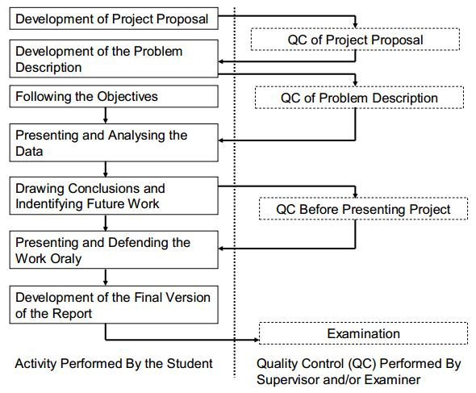

As Figure 1 illustrates, this process or lifecycle is composed of the following seven key steps: development of the project proposal; development of the problem description; following the objectives; presentation and analysis of the data; drawing conclusions and identifying future work; presenting and defending the work orally; and preparation of the final report. These steps are ordered and should be synchronized. The transition from one step to another should be validated by a quality control carried out by qualified persons known as the supervisors and the examiners.

As mentioned before, the supervision process requires different actors with precise relationships. We find typically in any dissertation project the following parties.

**2.3.1 The student**

A key actor and they are committed to carry out a project to achieve some learning outcomes (LOs) and goals. For this purpose, the student will seek support from a supervisor to identify suitable approaches and solve problems.

**2.3.2 The supervisor**

A person responsible for guiding, motivating, monitoring, and advising the student according to certain supervisory standards and regulations. The supervisor is skilled in carrying out projects in the student’s subject area.

**2.3.3 The examiner**

**A** person who assesses the student’s achievement either continuously or summative. The examiner guarantees the compliance of the student’s work and the supervision support to the defined higher education regulations and internal departmental procedures. So often, the examiner is seen as the quality evaluator and assuror. To this end, the supervisor needs to collaborate and co-ordinate with the supervisory team and the departmental administrators.

**2.3.4 The administrator**

Generally a team of persons who design the specification of modules, project, curriculum, guidelines and program of studies within an academic institution. These persons expect a high level of commitment from the student, the supervisor and the examiner. For this purpose, they design the procedures and guidelines to be used according to the latest higher education regulations, the internal charter and policy and the best practice recognized internationally. In addition to these key actors, other persons may be involved in the supervision process such as a student support adviser, a resource manager, and a trainings and workshop coordinator. All the different actors need to network with each other according to predefined guidelines. At the end of the supervision process, the student is assessed and the whole process is evaluated. As a result, new best practice will be reinforced and others revisited. Such a kind of critical evaluation of the supervisory process can be done by the supervisors themselves and external partners. Depending on the nature of the project and the level of study, some steps may be recurrent and the actors may be doubled. Figure 2, summarizes the different actors and their space of interaction. Despite all efforts, many supervisory issues may appear at any stage of the project lifecycle. For example the supervisor may face challenges to help his students controlling and conducting their research or projects independently with minimum assistance and interference. In other circumstances supervisors may find difficulty to build the students’ autonomy, reflection, motivation, and self-initiative to control their projects.

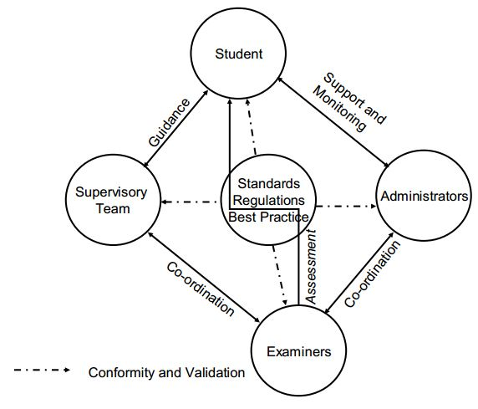

***Figure 2: Actors involved in a Supervision Process***

A rational balance between the supervisor’s and the student’s interests and ambition should be found. Without a clear supervision process and administrative tools to monitor the progress and check the conformity of the implementation of the supervision process, supervisory challenges will increase and student satisfaction will deteriorate. Authors in have identified a set of other critical success factors and they have integrated them into an analytical framework that can be applied to either supervision or traditional supervision practices.

More importantly, they determined that evaluation of supervision should be evidence-based (that is, dependent on how the supervisor’s students have achieved their educational goals including course completion and degree attainment). Although the supervisory dimensions of this model are useful, the evidence-based metric does not take into account student involvement in the process. Thus, this model does not fill the gap in evaluation of supervisory success. It also does not take into account external factors, such as candidate selection and admissions procedures and availability of external support and resources for students, which can affect the educational outcomes of students regardless of the supervisory skill or commitment. These findings consolidate our motivation to put in place a collaborative online e-supervision system to better control, monitor and evaluate the supervision experience for both student and supervisor.

**CHAPTER THREE**  
**METHODOLOGY**

* 1. **Introduction**

As stated earlier, our new system shares common advantages with existing proposed tools and tries to further enhance their limitations. Compared to similar online tools, our proposed system is central and collaborative at the same time. The specific requirements of each supervision actor are taken into consideration and the whole communication channel between the parties is carefully designed. From a design point of view, our system includes the following elements.

* 1. **Methodology**

The method that was used for data collection during this study are interview, direct observation and review of the project supervision system. An interview is method of data collection which is essentially a structured conversation where one participant asks questions, and the respondent provides answers, observation is the action or process of carefully watching someone, something or process while documentation is the review of the business enterprise’s existing which provides official information that serves as a record.

* 1. **Feasibility Studies**

This database contains all dissertation projects proposed by all teaching staff and students for a given department of discipline. Project proposals are uploaded to the system using an online form. The specification of each project includes an abstract, a list of keywords, a list of required resources (hardware and software), and preferable skills. The list of project proposals is classified or clustered into subject areas or research focus. To ease project search, this database is linked to the supervision system with a friendly Graphic User Interface (GUI). This GUI interface allows a quick, simple and advanced search. Students can browse projects whenever needed so as supervisor.

* + 1. **Supervisory Team Database**

This database contains the lists of tutors or supervisors. Supervisors are linked to the list of projects that they have suggested and they are classified according to their fields of expertise. These Fields of expertise match the keywords used in the project database. Within our system, supervisors can be grouped into small groups with respect to the different categories used to classify projects. When a student shortlists a project proposal of interest, the supervision system automatically proposes some potential supervisors (supervisors and second markers) for the project. Consequently, the system will ease and hasten supervisor allocation and assignment which will help to avoid significant delays in starting a project and saves the student’s times. Within this database, different roles and supervision quota can be assigned to each staff member. Such feature will help to control the staff workload across academic terms and ease the work of subject group leaders.

* + 1. **Performance Management Plan**

The former can use this performance management plan to monitor the progress and arrange a progress review meeting whenever needed. Our supervision tool allows the student and the supervisory team to check the current progress at any time and add comments whenever required. Progress report documents and charts can be produced and printed and exported by all involved actors depending on their access control policy with accordance to the supervision regulation.

* + 1. **Assessment Forms**

Depending on the assessment scheme and the nature of the dissertation project, our supervision system allows the supervisor and the examiners to complete and print electronic assessment forms. These forms can be accessed by the student at the end of the supervision process so that he will have a detailed feedback about his performance.

* + 1. **Communication interfaces**

The supervision system provides support for communication and group work. Example of features that are still under development include videoconferencing capability, integrated chat and whiteboard; online discussion, file management system and mail system.

The goals of the Iterative enhancement Model are as follows;

1. Working functionality can be developed quickly and early in the life cycle.
2. Results are obtained early and periodically.
3. Progress can be measured.
4. Testing and debugging during smaller iteration is easy.

## **Analysis of the Existing System**

In the manual system, all activities such as; document in, allocation of supervisors, getting to know the number of student that doing or done with their projects and keeping the completed projects are done manually. And if someone is interested in a certain completed projects, one must have to follow many manual processes before get it done.

## **Description of the System under Development**

The proposed system under development is an effective system that can take care of the likely occur errors if using manual system.

The system will be a server base application that will require an internet connection to operate. The system allows Admin to register new Supervisor by giving out their personal details which are then registered to the system, which then allows a user access to the system, thereby having the right and authentication to begin with the system.

Furthermore the system will be integrated with the functionalities of monitoring student and his/her supervisor and keeping a record of completed for future use.

Moreover the system tends to cover typical operations such as login, logout and profile management at both Admin and, Supervisors and the students.

## **Requirement Analysis**

The gathered requirements for the proposed system were analysed and classified into as functional and non-functional requirements.

### **Functional Requirements**

A functional requirement defines a function of a system or its component. A function is described as a set of inputs, the behaviour and outputs. It defines what a system is supposed to accomplish. The functional requirements for the (Effective Project supervision system) are as listed below;

1. A user shall be able to register.
2. A user shall be able to login.
3. A user shall be able to upload file/projects.
4. A user shall be able to download file/projects.
5. A user shall be able to view all uploaded file/projects.
6. A user shall be able to view a comment.
7. A user shall be able to give a score and grade
8. A user shall be able to view a score and grade
9. A user shall be able to add a comment
10. A user shall be able to logout of the system.

### **Non Functional Requirements**

Non-functional requirements are requirements that specify criteria that can be used to judge the operation of a system, rather than specific behaviours. In other words it also describes and specifies the performance, availability, usability and security of the system.

1. Security: the system shall prevent unauthorized access.
2. Performance: the system shall respond quickly to user request.
3. Usability: the system shall be easy to use and understandable.

## **Analysis of the System**

In order to present a graphical overview of the systems functionalities, the requirements analysis was presented using a use case diagram. Usually defining the interactions between a role (actor) and the system, to achieve a goal K.K.Aggarwal (2007). It is a methodology used in system analysis to identify, clarify and organize system requirements. The use case diagram of the proposed system under study is shown below.

**Admin**

**Supervisor**

**Student**

*Figure 3.1: Use case Diagram*

* 1. **Description Of The Use Case**

A use case is a written description of how users will perform tasks on your website. It outlines, from a user’s point of view, a system’s behaviour as it responds to a request. Each use case is represented as a sequence of simple steps, beginning with a user's goal and ending when that goal is fulfilled usability (2019).

* + 1. **Register Account;**
    2. **Introduction**: Register account will allow the user to enter his details for him to be able to access the site.
       1. **Actor:** Stu dent
       2. **Pre-condition:** none
       3. **Post condition:** if the use case is successful account will be created, if not error will be displayed.
       4. **Flow of event**
       5. Basic flow

1. The system will request user to enter his detail
2. User sends detail to the database for validation.
3. Successful message display.
4. Alternate flow
5. The system will request user to enter his detail
6. User sends detail to the database for validation.
7. Error message display to the user.
   * 1. **Log in**
        1. **Introduction**: Log in will allow the user to enter the system to start using the system.
        2. **Actor:** Student and Admin.
        3. **Pre-condition:** None
        4. **Post condition:** if the use case is successful, the log in will be displayed, if not nothing will be displayed.
        5. **Basic of event**
     2. **Basic flow**
        + 1. The actors enter username and password.
          2. The system validates the username and password
          3. The user is logged into the system. Success message is displayed
          4. The use case ends.
8. **Alternate flow** 
   1. The actors enters username and password
   2. The system validates the username and password
   3. The username or password is invalid, an error message is displayed.

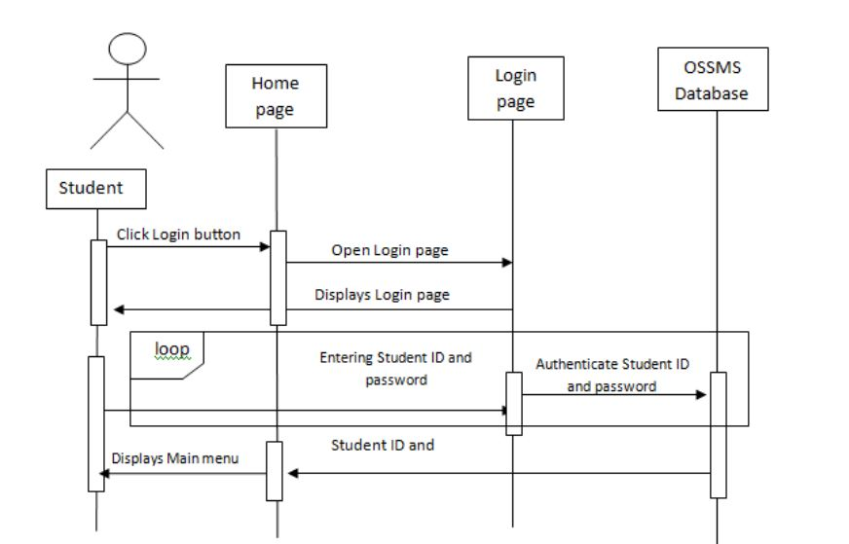

**Figure 2:** Sequence Diagram of “Signup”

This use case is initiated by all kinds of users (students, administrators and supervisors) to view titles of the abstracts. The initial requirement for this use case is to do a search and to obtain results this use case prompts the students to enter their usernames and passwords to be identified by the system when they want to access the system.

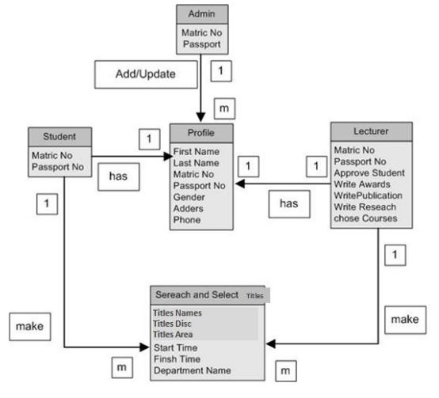 ***ERD - Entity Relationship Diagram for Online***

This diagram shows the relationship between the entities in the system. Administrative staff, Supervisor and students have Metric Numbers and Passport Numbers to login to the system, One Administrative staff can create many users profiles with every supervisor and student having one profile. The profile contains user names and full name, password, address, telephone number and change of password, These attributes are inherited by both supervisor and students who have their Metric Number and Passport Number in the database of the university, supervisors has titles and courses, the Student and supervisor have one - many relationship with the OSSMS system, this means every supervisor and student can make only one title in the system.

**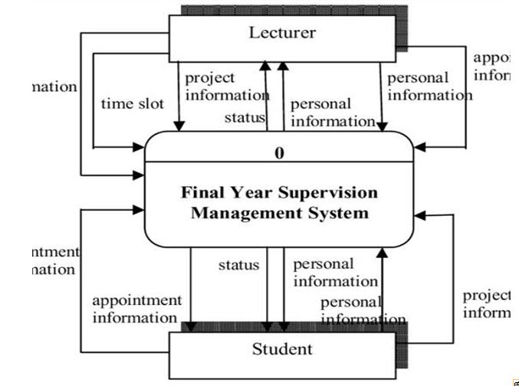 *Data Flow diagram (DFD)***

Information

Information

Projects information

Management information

Information

**Flow diagram** is a collective term of a [diagram](https://en.wikipedia.org/wiki/Diagram) that represent a flow or set of dynamic relationships in a system. The term flow diagram is also used as a synonym for [flowchart](https://en.wikipedia.org/wiki/Flowchart), and sometimes as a counterpart of the flowchart. Flow diagrams are used to structure and order a [complex system](https://en.wikipedia.org/wiki/Complex_system), or to reveal the underlying structure of the elements and their interaction.

**3.7. Development Methodology**

The developement approach for this project is going to the Rapid Application Development (RAD.

Rosa Delima and Halim Budi Santoso (2017) defined Rapid Application Development (RAD) as a methodology used to develop software. This method is able to reduce time to develop software. This becomes consideration in order to choose the Rapid Application Development as a methodology to develop Dutatani Website. Dutatani is a portal and a part of Integrated Agriculture Information System (IAIS). IAIS is an agriculture information system that has some subsystems that are connected and linked to each other. It also has an integrated database. In particular, Dutatani is able to manage user, manage content, and manage link in the IAIS. This website will be a link to other applications in the IAIS. This article especially discusses the development of the Dutatani Website using Rapid Application Development that is implemented by combining iterative development and system prototyping. There are some phases in the development using the RAD: planning, analysis, main design specific design, implementation and testing, and integrating prototype. This system was developed by a team which consists five members. The implementation of this prototyping technique was done by dividing five people into two groups in which each group had different responsibilities to different module/functions. This website had been developed within 150 days. Thus, in implementing the RAD, it is important for the team leader to monitor continuously. Monitoring is a useful technique to ensure the productivity and 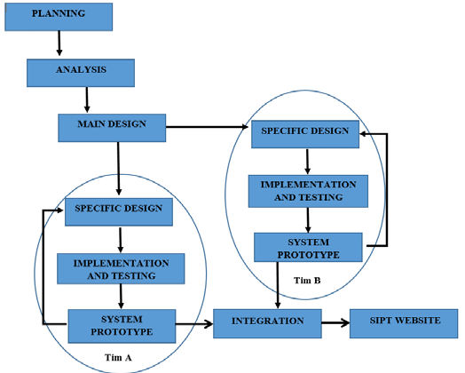performance of each members in order to gain optimal development process.

***Rad application development***

**3.8. Choice and Justification of Programming Language Used**

So many programming languages were considered in the cause of designing this software. A lot of factors were put into consideration which includes online database access, data transmission via networks, database security, database retrieval online, multi user network access, online data capture, etc. The choice for PHP- MySQL was made to enable us achieves the above set objectives. Moreover, PHP- MySQL is very user friendly and enables the design of an interface that can be modified programmatically. Also MySQL database is a robust database that can guarantee database integrity, database protection, and accommodate large database.

**References**

1. Baptista, A. V., “Challenges to doctoral research and supervision quality: A theoretical approach”, rocedings of a Social and Behavioral Sciences Pages 1-15, 2011.
2. Manathunga, C., “Supervision as mentoring: the role of power and boundary crossing”, Studies in Continuing Education, 29 (2), 207-221, 2007.
3. Mikael Berndtsson, Jorgen Hansson, Bjorn Olsson, and B. Lundell, “Thesis Projects: A Guide for Students in Computer Science and Information Systems”, Springer-Verlag London Ltd; 2nd Edition, ISBN-10: 1848000081, 25 Oct 2007.
4. Firth, A., & Martens, E., “Transforming supervisors? A critique of post-liberal approaches to research supervision”, Teaching in Higher Education, 13 (3), Pages 279-289, 2008.
5. Nulty, D., Kiley, M., & Meyers, N., “Promoting and recognising excellence in the supervision of research students: an evidence-based framework”, Assessment & Evaluation in Higher Education, 34 (6), Pages 693-707, 2009.
6. Buttery, E. A., Richter, E. M., & Filho, W. L., “An overview of the elements that influence efficiency in postgraduate supervisory practice arrangements. International Journal of Educational Management, 19 (1), Pages 7-26, 2005.
7. Stacey, E., & Fountain, W., “Student and Supervisor Perspectives in a Computer-Mediated Research Relationship”, Proceedings of the Annual Conference of the Australasian Society for Computers in Learning in Tertiary Education, pp. 519-528, 2001.
8. Paliktzoglou, V., & Suhonen, J., “Part-time online PhD reflection: train of thoughts”. Procedia Computer Science, 3, 149-154, 2011.
9. Kay MacKeogh, “Using Moodle to Support Peer and Group Online Undergraduate Research Supervision”, EdTech 2008, the Ninth Annual Irish Educational Technology Users' Conference, 23 May 2008.
10. Loughborough University, “ProjectList information site”, retrieved from: http://projectlist.lboro.ac.uk/